Fuel Efficiency Prediction and Analysis for Automotive Insights
Prepared By: Rahit Saha
Tools & Technologies:
- Python
- Pandas
- NumPy
- Seaborn
- Matplotlib
- Scikit-Learn
- XGBoost
- SHAP
Executive Summary
In an increasingly competitive automotive landscape, fuel efficiency has become a critical driver of product success, operational cost reduction, and environmental compliance. Manufacturers that can accurately predict and optimize fuel efficiency during the design stage gain a significant advantage through improved vehicle performance, lower development costs, and stronger market positioning.
This project leverages machine learning to predict vehicle fuel efficiency (Miles Per Gallon, MPG) using key automotive attributes, including engine specifications, vehicle weight, acceleration, manufacturing year, and country of origin. A comprehensive analytical framework was developed encompassing data preprocessing, exploratory data analysis, feature engineering, cross-validation, hyperparameter tuning, and model interpretability techniques to ensure both accuracy and reliability.
Three predictive models were evaluated: Linear Regression, Random Forest Regressor, and XGBoost Regressor. Following rigorous validation and optimization, the Tuned Random Forest Regressor emerged as the best-performing model, achieving an R² score of 0.914, MAE of 1.59 MPG, and RMSE of 2.15 MPG. These results demonstrate the model's ability to explain more than 91% of the variation in vehicle fuel efficiency, providing highly accurate and dependable predictions.
Beyond predictive performance, the analysis identified the key factors influencing fuel efficiency. Vehicle weight, horsepower, engine displacement, and model year were found to be the strongest drivers of MPG. The findings indicate that lighter vehicles, optimized engine configurations, and advancements in automotive technology significantly contribute to improved fuel economy.
Business Impact
The successful development of this predictive framework demonstrates how data-driven decision-making can transform automotive design and manufacturing strategies. By enabling fuel efficiency to be estimated before production, the model allows manufacturers to evaluate design alternatives, identify efficiency trade-offs, and prioritize engineering decisions with greater confidence. This reduces reliance on costly trial-and-error testing while accelerating the development of fuel-efficient vehicles.
With over 91% predictive accuracy, the solution provides actionable insights that can support lower production and operating costs, improved regulatory compliance, enhanced customer satisfaction, and stronger competitive differentiation. By converting historical vehicle data into strategic intelligence, this project establishes a scalable foundation for smarter product development and long-term business value creation.
Key Achievements
- Developed a robust machine learning solution for fuel efficiency prediction.
- Achieved R² = 0.914 using a Tuned Random Forest Regressor, significantly outperforming the baseline model.
- Identified vehicle weight, horsepower, and engine displacement as the primary drivers of fuel efficiency.
- Delivered interpretable insights to support engineering and design optimization.
- Established a scalable, data-driven framework to support future automotive innovation and decision-making.

Table of Contents
- Introduction
- Business Understanding
- Dataset Description
- Data Preparation
- Exploratory Data Analysis
- Feature Engineering
- Model Development
- Hyperparameter Optimization
- Model Evaluation
- Model Interpretability
- Business Insights
- Dashboard & Visualization
- Recommendations
- Conclusion
- Future Scope
- References

1. Introduction
The automotive industry continuously seeks ways to improve vehicle performance while reducing fuel consumption.
Machine learning allows manufacturers to leverage historical automotive data to predict fuel efficiency and understand how vehicle attributes impact performance.
The objective of this project is to develop an accurate, interpretable, and scalable predictive model for fuel efficiency prediction.

2. Business Understanding
Business Objectives
- Predict vehicle fuel efficiency accurately.
- Identify major factors affecting MPG.
- Assist manufacturers in making data-driven design decisions.
- Improve vehicle performance while reducing operating costs.
Success Criteria
Technical Success
- Achieve high predictive performance.
- Outperform baseline methods.
- Minimize prediction error.
Business Success
- Generate actionable insights.
- Improve understanding of efficiency drivers.
- Support vehicle design optimization.

3. Dataset Description
Dataset Overview
The dataset contains vehicle specifications and fuel efficiency measurements.
Target Variable
Variable | Description
MPG | Miles Per Gallon
Predictor Variables
Feature | Description
Cylinders | Number of engine cylinders
Displacement | Engine size
Horsepower | Engine power
Weight | Vehicle weight
Acceleration | Acceleration capability
Model Year | Manufacturing year
Origin | Country of origin

Dataset Characteristics
Metric | Value
Records | 398
Features | 8
Target | MPG
Missing Values | Present in Horsepower

4. Data Preparation
Data Cleaning Activities
Missing Value Handling
The horsepower variable contained missing values represented by "?".
Actions performed:
- Converted horsepower to numeric format.
- Replaced missing values using median imputation within a machine learning pipeline.
Duplicate Handling
- Duplicate observations checked.
- Duplicates removed if detected.
Data Leakage Prevention
To ensure reliable evaluation:
- Train/Test Split performed before preprocessing.
- Imputation performed inside pipeline.
- One-Hot Encoding performed inside pipeline.
- Cross-validation executed using complete pipelines.

5. Exploratory Data Analysis (EDA)
Fuel Efficiency Distribution
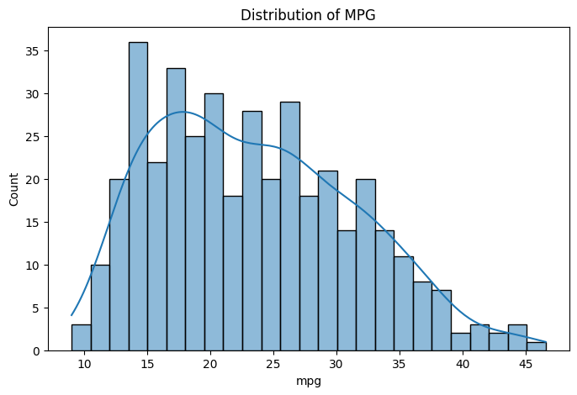
Key Observation:
- Most vehicles fall between 15 and 35 MPG.

MPG vs Weight
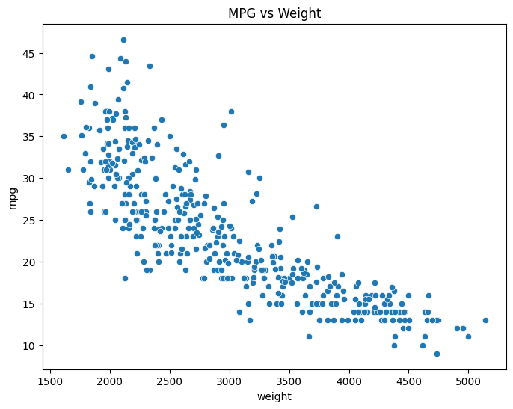
Key Observation:
- Weight has a strong negative relationship with MPG.

MPG vs Horsepower
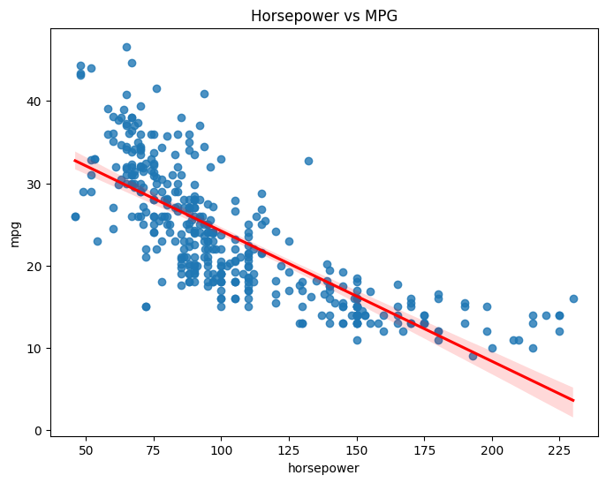
Key Observation:
- Higher horsepower generally reduces fuel efficiency.
MPG vs Cylinders
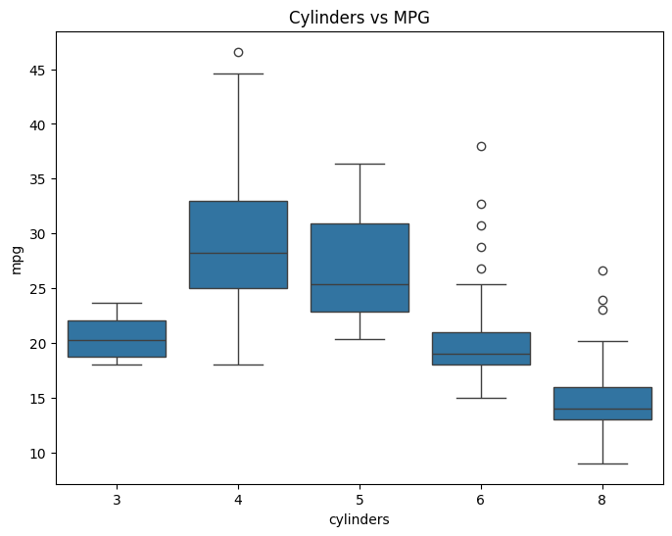
Key Observation:
- Fuel efficiency decreases as cylinder count increases.
MPG by Origin
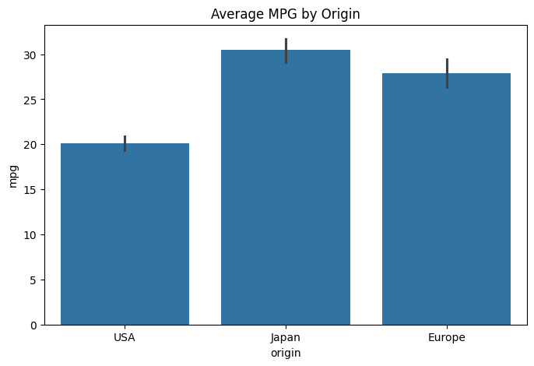
Key Observation:
- Japanese vehicles demonstrate the highest average fuel efficiency.
MPG Trend by Model Year
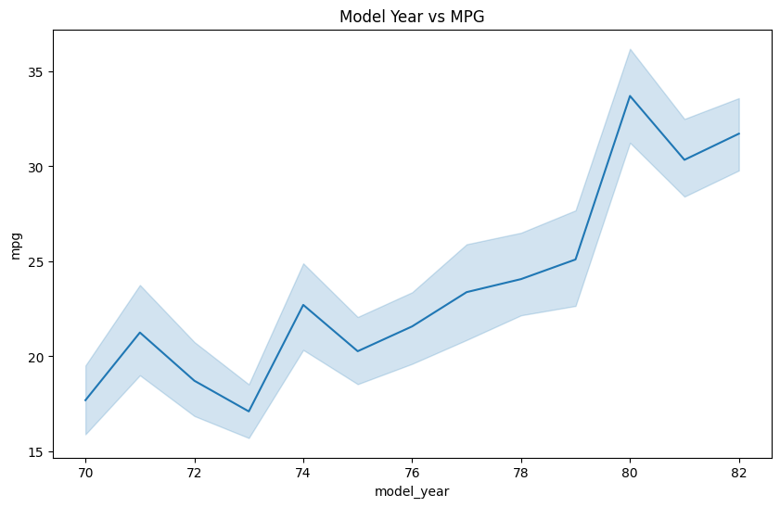
Key Observation:
- Fuel efficiency improves in later model years.

6. Feature Engineering
Features Used
- Cylinders
- Displacement
- Horsepower
- Weight
- Acceleration
- Model Year
- Origin
Removed Features
Car Name
Reason:
- Identifier only
- No predictive value
Encoding
Origin was transformed using One-Hot Encoding.

7. Model Development
Three machine learning algorithms were evaluated.
Model 1: Linear Regression
Purpose:
- Baseline interpretable model

Model 2: Random Forest Regressor
Advantages:
- Captures non-linearity
- Handles feature interactions
- Provides feature importance

Model 3: XGBoost Regressor
Advantages:
- Gradient boosting framework
- Strong predictive performance

8. Hyperparameter Optimization
Validation Strategy
K-Fold Cross Validation
Parameters:
- k = 5
- Shuffle = True
- Random State = 42
Hyperparameter Search
Method:
- RandomizedSearchCV
Models Tuned:
- Random Forest
- XGBoost
- Optimization Metric:
- R² Score

9. Model Evaluation
Evaluation Metrics
Mean Absolute Error (MAE)
Average absolute prediction error.
Root Mean Squared Error (RMSE)
Measures magnitude of error.
R² Score
Proportion of variance explained by the model.

Model Performance
Model | MAE | RMSE | R²
Linear Regression | 2.288 | 2.888 | 0.845
XGBoost Tuned | 1.774 | 2.455 | 0.888
Random Forest Tuned | 1.588 | 2.146 | 0.914

Best Model
Random Forest Tuned
Reasons:
- Highest R²
- Lowest MAE
- Lowest RMSE

10. Model Interpretability
Feature Importance Analysis
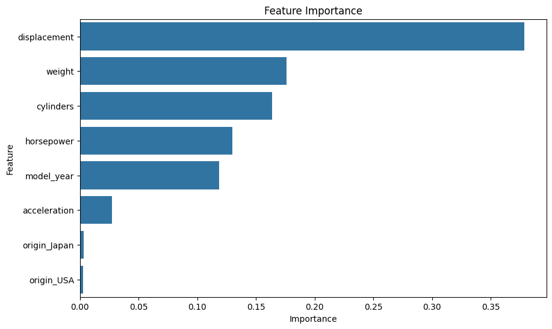
Expected ranking:
- Weight
- Horsepower
- Displacement
- Model Year
- Cylinders

SHAP Analysis
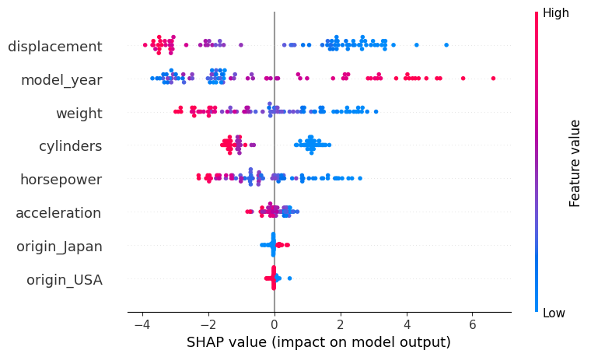Major Findings
- Higher weight reduces MPG.
- Higher horsepower reduces MPG.
- Newer vehicles improve MPG.
- Smaller engines contribute positively to fuel efficiency.

11. Business Insights
Insight 1
Vehicle weight is the strongest factor impacting fuel efficiency.
Recommendation
Reduce vehicle weight using lighter manufacturing materials.

Insight 2
Large engines significantly reduce MPG.
Recommendation
Optimize engine size and improve combustion efficiency.

Insight 3
Fuel efficiency improved over time.
Recommendation
Continue investing in newer engine technologies.

Insight 4
Japanese-origin vehicles demonstrate superior MPG performance.
Recommendation
Study design characteristics of high-efficiency vehicle platforms.

12. Recommendations
Based on the analysis:
- Reduce vehicle weight wherever possible.
- Optimize engine size and horsepower balance.
- Use fuel-efficient design principles observed in high-MPG vehicles.
- Employ machine learning predictions during vehicle development stages.
- Incorporate predictive analytics into product planning and design decisions.

13. Conclusion
In conclusion, this project successfully demonstrates how machine learning can be leveraged not only to predict fuel efficiency with high accuracy but also to generate actionable business insights that enable manufacturers to design more efficient, cost-effective, and competitive vehicles.
Key Results
- Best Model: Random Forest Regressor (Tuned)
- MAE: 1.59 MPG
- RMSE: 2.15 MPG
- R² Score: 0.914
The model successfully explains over 91% of the variation in fuel efficiency and provides actionable insights for vehicle design optimization.

15. Future Scope
Potential future enhancements include:
- Collecting larger and more recent automotive datasets.
- Incorporating hybrid and electric vehicle data.
- Real-time fuel efficiency prediction APIs.
- Advanced explainability using SHAP dependence plots and PDPs.
- Automated vehicle design optimization.

16. References
- Auto MPG Dataset
- Scikit-Learn Documentation
- XGBoost Documentation
- SHAP Documentation
- Python Data Science Handbook
Appendix
Include:
- Full code
- Hyperparameter configurations
- Cross-validation results
- Additional visualizations
- Model comparison outputs

THANK YOU

